**Artificial Intelligence 1**

**Programming Assignment 1**

Sai Subhash Yalamadala

UTAID**:** 1002031729

Problem 1:

**Missionaries and Cannibals Solution:**

For problems, I have modified Rusell’s code which is available on the website to solve the problem. To check the correctness of the search I have written traverse and traverse_verso functions to print the actions as well as the sequence for each state.

Source code files: “miss.lisp”

Execution Steps:

* Open Terminal
* Goto CLISP environment
* To load the file (load “miss.lisp”)
* Enter the total number of missionaries, and cannibals followed by boat size : (15 15 6)

**Output**:

The above output shows the sequence of moves in order missionaries and cannibals from left to right. It also shows the boat capacity and the number of missionaries and cannibals in each state. The initial state and goal state along with the current boat size are provided for each and every traverse from right to left until the desired state is reached.

* According to the problem statement when given 20 cannibals and 20 missionaries the output fetched was,

**Output**:

For 20 cannibals and 20 missionaries and 6 Boat size, the sequence of states from the left riverbank to the right riverbank is shown in the output above.

**Program Description**:

The traverse and traverse_verso functions which is used to transfer/move the missionaries and cannibals from left river bank to the right river bank. The variables are being assigned for the following operations such as, missionaries initial state traverse, cannibals initial state traverse, missionaries count, cannibals count, missionaries goal state traverse, cannibals goal state traverse.

Problem 2:

**8 Puzzle Problem**

Source code files: “epuzzle.lisp”

Execution Steps:

* Open Terminal
* Run clisp “epuzzle.lisp”
* Enter the 8 puzzle format
* Example ((E 1 3) (4 2 5) (7 8 6))

**Output:**

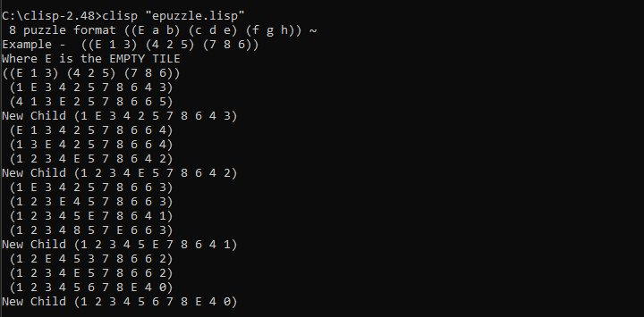

The list is being used like ((E 1 3 ) (4 2 5) (7 8 9)) to display the state. The actions are performed in each state are printed. The number of misplaced tiles are considered as the heuristic function.

For a* search, in the first state total 4 nodes are expanded and 4 actions are taken and for the second state 7 total 7 nodes are expanded and 5 actions are taken. For no repeat-a* the fetched results are same as above until two states but different for third state.